Dear 5th Grade Parents and Students,
We would love to see all the 5th graders become the best readers they can be! Please have your child read for a minimum of 25 minutes daily. Please record the number of minutes and the name of the book read on each day of the month. The goal is to read at least 5 days a week! At the end of each month, students need to bring back the signed calendar for a small reward. A new calendar will be sent home each month. Independent reading is an important part of your child’s literacy development. Thank you for helping your child to become a lifelong reader!
Sincerely,
The Fifth Grade Teachers
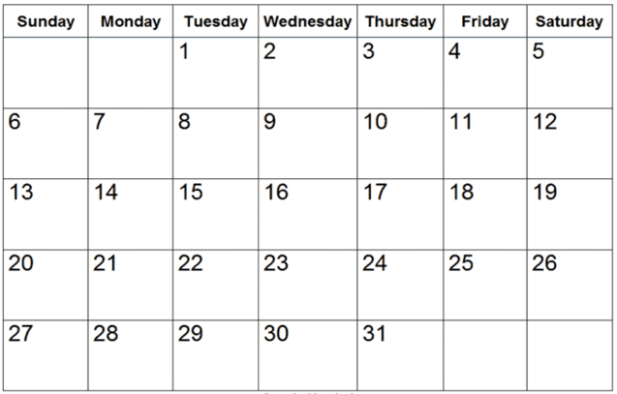
Sign and return this Reading Log by Monday, January 4th.
How many minutes did you read this month? ________
Student’s Name:_______________________________________
Parent’s Signature:________________________________________

