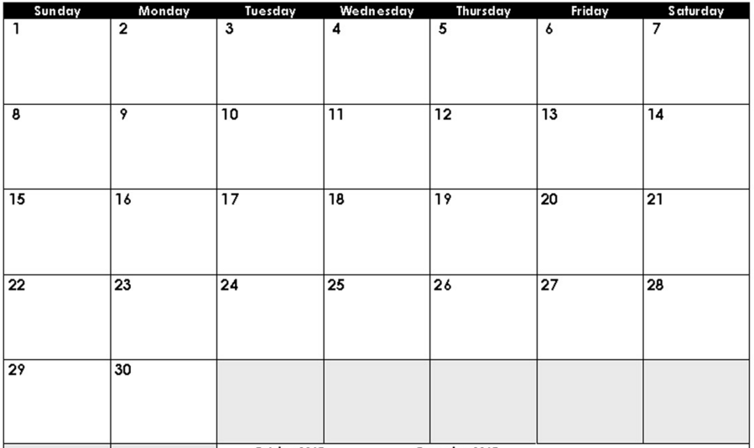
Dear 5th Grade Parents and Students,
We’d love to see all 5th graders become the best readers they can be! Please have your child read for a minimum of 25 minutes daily. Please record the number of minutes read on each day of the month. The goal is to read at least 5 days a week! At the end of each month, students need to bring back the signed calendar for a small reward. A new calendar will be sent home each month. Independent reading is an important part of your child’s literacy development. Thank you for helping your child to become a lifelong reader! Also, please write THE NAME OF THE BOOK on this sheet
Sincerely,
The 5thGrade Teachers at Cloverdale School
Sign and return this Reading Log by Tuesday, December 1st.
How many minutes did you read this month? ________ Minutes
Student’s Name:__________________________________________
Parent’s Signature:________________________________________

