C:\Users\jrybowia\AppData\Local\Microsoft\Windows\Temporary Internet Files\Content.IE5\0GU60ETF\MC900053352[1].wmf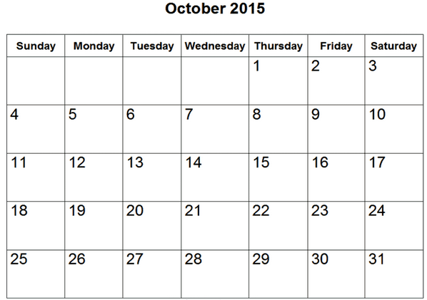

Dear 5th Grade Parents and Students,  
 I’d love to see all 5th graders become the best readers they can be! Please have your child read for **a minimum of 25 minutes daily**. Please record the number of minutes read on each day of the month. The goal is to read at least **5 days a week**! At the end of each month, students need to bring back the signed calendar for a small reward. A new calendar will be sent home each month. Independent reading is an important part of your child’s literacy development. Thank you for helping your child to become a lifelong reader!   
 Sincerely,  
 The Fifth Grade Teachers

Sign and return this Reading Log on NOVEMBER 1st.

Total minutes you read this month ________ minutes  
  
Student’s Name:__________________________________________

Parent’s Signature:________________________________________