Dear **5th** Grade Parents and Students,  
 I’d love to see all 5th graders in Room 214 to become the best readers they can be! Please have your child read for **a minimum of 25 minutes daily**. Please record the number of minutes and **the book that is being read** on each day of the month. The goal is to read at least **5 days a week**! At the end of each month, students need to bring back the signed calendar for a small reward. A new calendar will be sent home each month. Independent reading is an important part of your child’s literacy development. Thank you for helping your child become a lifelong reader!   
 Sincerely,  
 Mrs. Dravet

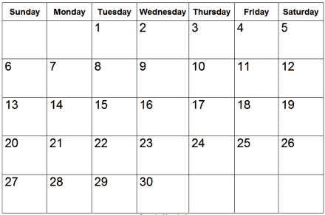happy-pencil.png

Sign and return this Reading Log by **Thursday,** **October 1st**.

Total number of minutes read this month ________________  
  
Student’s Name:__________________________________________

Parent’s Signature:________________________________________